SIMATS ENGINEERING
ASSESSMENT TOOL 3

COURSE NAME: Artificial Intelligence COURSE CODE: CSA17

COURSE OUTCOME COVERED

CO2: Experiment search and game-solving techniques such as Greedy Search, A*, CSP, Minimax, and Alpha-Beta pruning with heuristic functions for solving complex AI problems efficiently. (BL3)

Assessment Tool Weightage: 40%

Duration: 1 Hour
QUESTIONS: 3 Total Marks:30

Annexure A

Dry Run Evaluation

Code of Conduct:

I Jaya Suriya N (192511271) (Name / Reg No) certify that this submission is my original work and that I have adhered to the guidelines specified for this assessment.
I understand that any violation of academic integrity rules will result in disciplinary action.

Signature of the student: Jaya Suriya N

Annexure A

Dry Run Evaluation

Student 11: Jaya Suriya N | Register Number: 192511271

- Question 6 – Nature of Environment
An AI robot is designed to play chess. Classify the environment as fully/partially observable, deterministic/stochastic, sequential/episodic, static/dynamic, discrete/continuous and single-agent/multi-agent. Justify each classification.

2. Question 7 – Greedy Best-First Search
Use the displayed graph and assign the following heuristic values: h(A)=6, h(B)=2, h(C)=4, h(D)=1, h€=3, h(G)=0.
Perform Greedy Best-First Search from S to G and trace the priority queue.
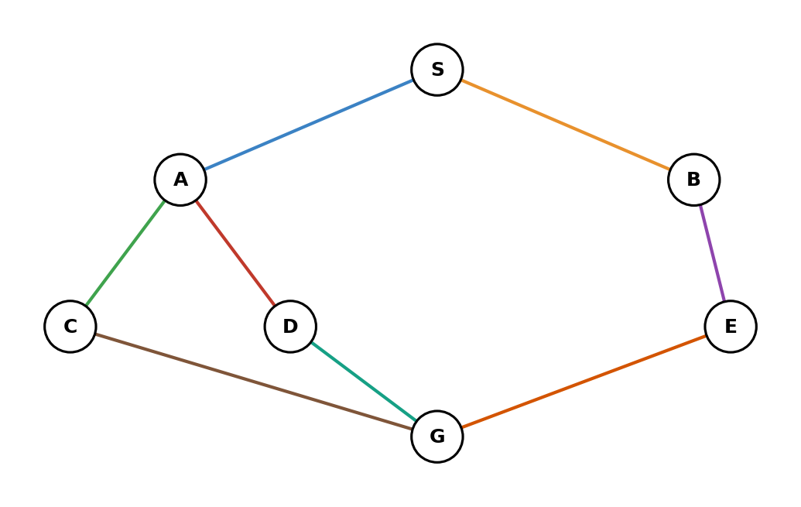
Iteration | Priority Queue | Expanded | h(n)
1
2
3
4
5

3. Question 8 – A* Search
Use f(n)=g(n)+h(n). Perform A* search on the displayed graph.
Use the following values: S(0,7), A(2,5), B(3,4), C(4,3), D(5,2), E(6,1), G(8,0).

Iteration | OPEN | Expanded | g | h | f
1
2
3
4
5

RUBRICS FOR CALCULATION

Criteria | Weightage (%) | Level 4 – Exemplary (4) | Level 3 – Proficient (3) | Level 2 – Developing (2) | Level 1 – Beginning (1)
Understanding of Search Problem | 20 | Clearly understands the search problem, initial state, goal state, and search strategy. | Understands the problem with minor misunderstandings. | Demonstrates partial understanding of the search problem. | Shows little or no understanding of the search problem.
State Expansion and Dry Run Execution | 30 | Correctly traces every iteration, expands nodes accurately, and maintains the Queue/Stack/Priority Queue without errors. | Performs most iterations correctly with minor mistakes in state expansion or data structure updates. | Performs only some iterations correctly; several errors in tracing or node expansion. | Unable to correctly perform the dry run or expand states.
Application of Search Algorithm | 20 | Applies the selected algorithm (BFS/DFS/UCS) correctly, following all algorithmic rules. | Applies the algorithm correctly with a few procedural errors. | Applies only basic algorithm steps with noticeable mistakes. | Fails to apply the correct search algorithm.
Accuracy of Solution Path | 20 | Identifies the correct traversal order/solution path and goal state with proper justification. | Solution path is mostly correct with minor errors. | Partially correct solution path; goal may not be reached correctly. | Incorrect or incomplete solution path.
Presentation and Logical Reasoning | 10 | Queue/Stack/Priority Queue updates, state diagrams, and explanations are neat, organized, and logically presented. | Presentation is clear with minor organizational issues. | Limited explanation and organization; reasoning is partially clear. | Poor presentation with unclear or missing reasoning.

1. Question 6 – Nature of Environment: Chess
An AI robot playing chess operates in the following environment:
Property | Classification | Justification
Observability | Fully observable | The complete chessboard, including all pieces and their positions, is visible to the players.
Determinism | Deterministic | A legal chess move has a predictable result. There is no randomness involved in the movement of pieces.
Sequential | Sequential | Every move affects the future state of the game. A current decision can influence many later moves.
Static/Dynamic | Dynamic | The board changes after every move by the opponent. Therefore, the environment changes while the agent is making decisions.
Discrete/Continuous | Discrete | The board has 64 discrete squares, and there are a finite set of legal moves at each state.
Single/Multi-agent | Multi-agent | Chess involves two competing agents: the AI and the opponent. Each tries to maximize its own chance of winning.

Final classification
Chess = Fully Observable + Deterministic + Sequential + Dynamic + Discrete + Multi-agent

2. Question 7 – Greedy Best-First Search
The graph image is not included/visible in your message. The heuristic values alone are not enough to determine the priority queue because I need to know which nodes are connected to which.
Please upload the displayed graph so I can give you the exact iteration-by-iteration priority queue and expanded nodes.
Greedy Best-First Search uses:
$$f\left(n\right)=h\left(n\right)$$
Given:
Node | A | B | C | D | E | G
h(n) | 6 | 2 | 4 | 1 | 3 | 0

The rule is:
Always expand the node with the smallest heuristic value $h\left(n\right)$.
For example, if the successors of S were A, B and C:
OPEN = [A(6), B(2), C(4)]
Greedy Best-First Search would select:
B(2)
because $2<4<6$.
I need the actual graph connections to complete the requested table accurately.

3. Question 8 – A* Search
This question also depends on the displayed graph, which is not visible in the message.
A* uses:
$$\boxed{f\left(n\right)=g\left(n\right)+h\left(n\right)}$$
Given values:
Node | g(n) | h(n)
S | 0 | 7
A | 2 | 5
B | 3 | 4
C | 4 | 3
D | 5 | 2
E | 6 | 1
G | 8 | 0

Therefore:
Node | g | h | f = g+h
S | 0 | 7 | 7
A | 2 | 5 | 7
B | 3 | 4 | 7
C | 4 | 3 | 7
D | 5 | 2 | 7
E | 6 | 1 | 7
G | 8 | 0 | 8
The actual OPEN queue and expansion order require the graph's edges.

Important observation
All intermediate nodes have:
$$f\left(n\right)=7$$
while:
$$f\left(G\right)=8$$
So the exact order in which A, B, C, D and E are expanded depends on their connections in the displayed graph and the tie-breaking rule used by A*.

